**User Manual**

**DPClusSBO1.1**

Table of Contents

1. Parameter setting 2

2. Mouse interaction 2

3. Simple Graph Clustering 2

3.1 Input simple graph: 3

3.2 Filtering cluster set 3

Filter using overlapping coefficient: 3

Join cluster using overlapping coefficient: 3

Filter using different size: 4

Filter using cluster no: 4

3.3 Plot cluster set: 4

Circular layout of cluster set 5

View individual cluster 5

Hierarchical cluster view: 6

Hierarchical cluster node: 6

4. Bi clustering two way 7

4.1 Input file: 7

4.2 Filter/ Join: 8

4.3 View bicluster: 9

Matrix view: 9

Graph view: 9

Single view of a bicluster: 10

Hierarchical bicluster view: 10

Hierarchical bicluster node: 11

5. Save Image 11

# 1. Parameter setting

Default value for generating simple cluster: density=0.5, CP=0.5

Default value for generating bicluster: density=0.5, CP=0.5, Relation number = 3, Tanimoto coefficient = 0.33, Psc=0.5

For generating biclique density=0.5, CP=0.5, Relation number = 3, Tanimoto coefficient = 0.33, Psc=1

Usually changing density 0.5 to 0.9 will generates high density cluster. All parameters can be changed from range 0 to 1.

# 2. Mouse interaction

All graphical views will allow the user to rearrange the nodes by mouse interaction.

# 3. Simple Graph Clustering

Select ***simple cluster*** menu item from Graph data

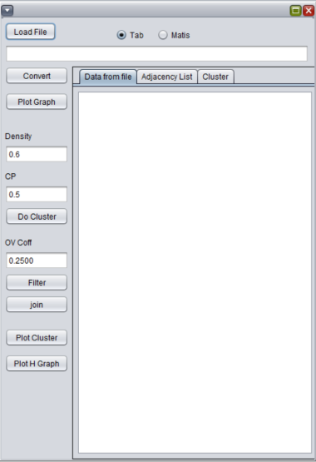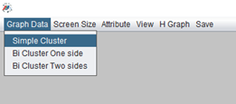

3.1 Input simple graph: The input file should be a tab-separated text file containing two columns without any header. Each row of this file represents an edge to the corresponding nodes. Also, METIS format containing a neighbor list of serialized nodes separated by space can be used.

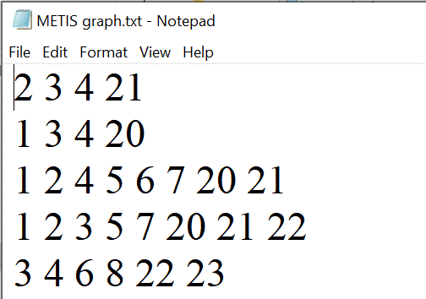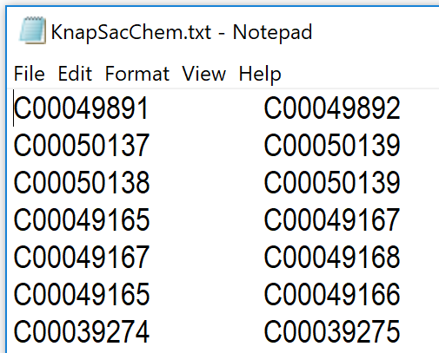

Click *load file* button and select the text file of network data

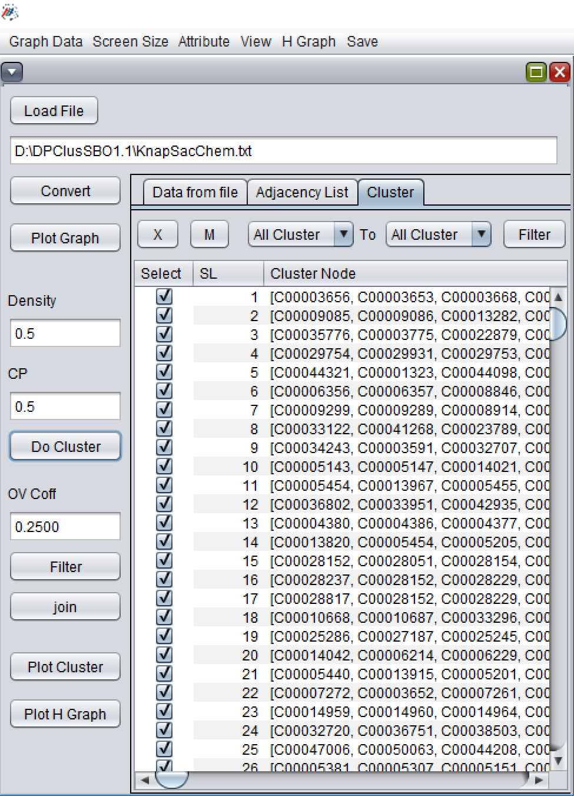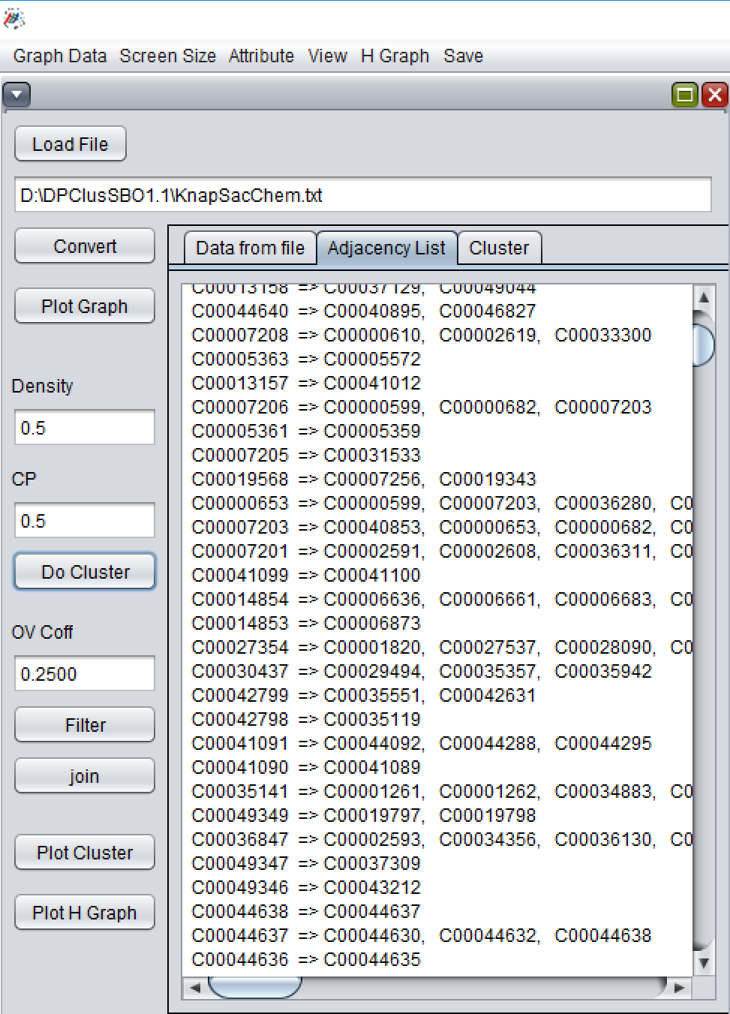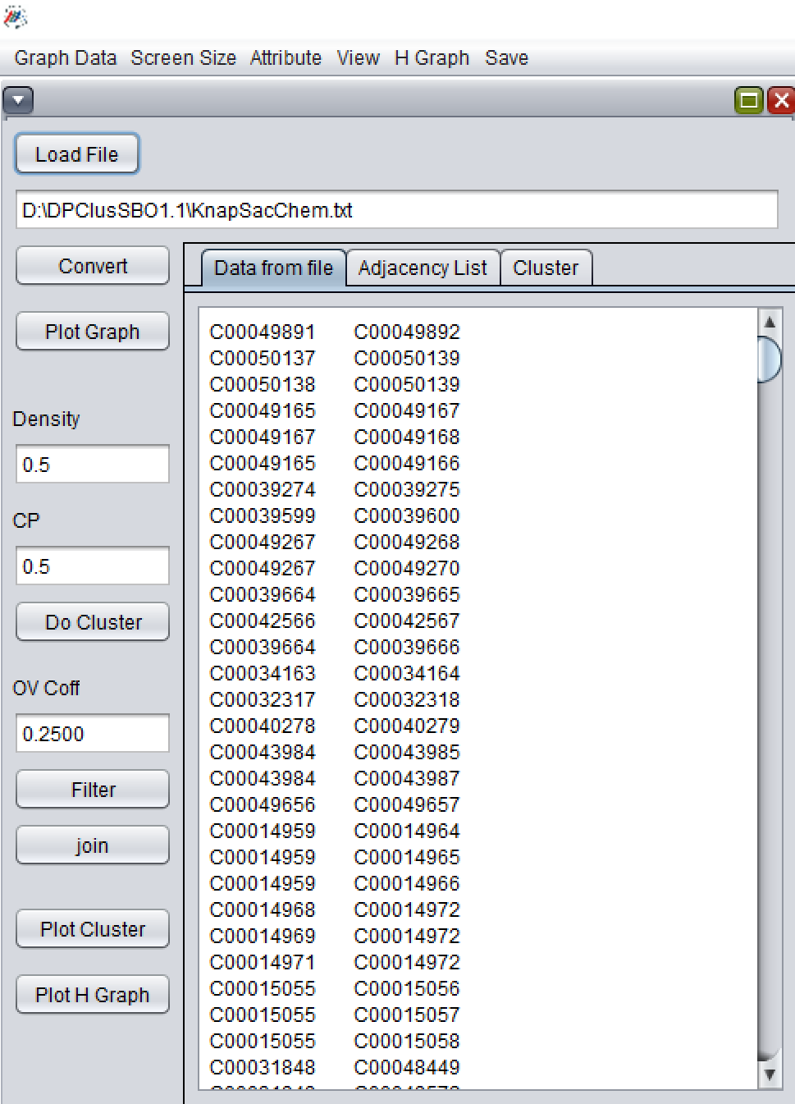

Enter the appropriate parameter for Cluster density (Density), Cluster property (CP). The default value for these parameter values is 0.5. Click convert to generate the adjacency list of the network. Click *Do cluster* button to generate a cluster set.

## 3.2 Filtering cluster set

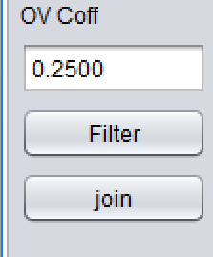Filter using overlapping coefficient: Default overlapping coefficient is 0.25. Click Filter to filter small sized cluster between two clusters which have more than 0.25 overlapping. This value indicates that more than half of the nodes between the two clusters are common.

Join cluster using overlapping coefficient: Click *join* button to join cluster set which has more than 0.25 overlapping coefficient.

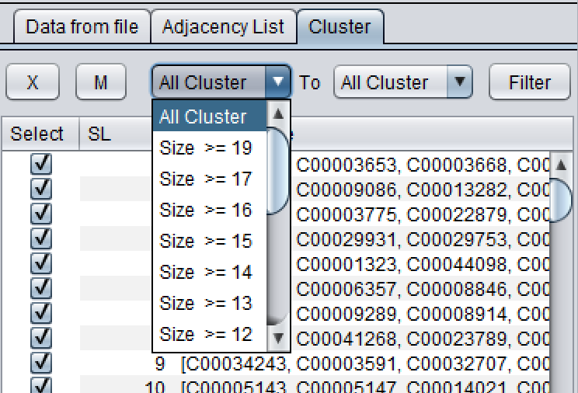Filter using different size: Two combo box representing the node size of different clusters in descending order can be used to select desired set of cluster set based on size range. Select different range from any one or the combination of two combo box and click *filter* button***.***

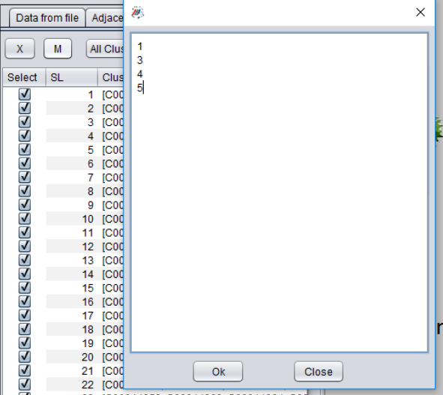Filter using cluster no:  Clicking the button *M* will allow a text box to enter the number of different cluster in each line. Click ok to select the desired cluster in the table. Click *X* button to filter all clusters other than the selected set.

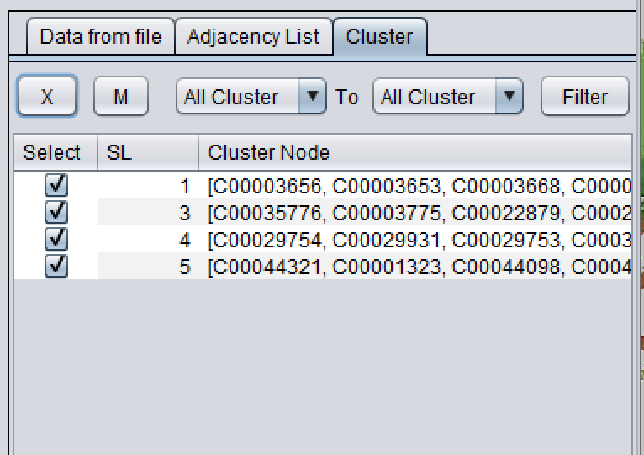

## **3.3 Plot cluster set:**

Click the button *Plot cluster*. Red nodes indicate the overlapping nodes. Each node in the dataset is plotted only once.

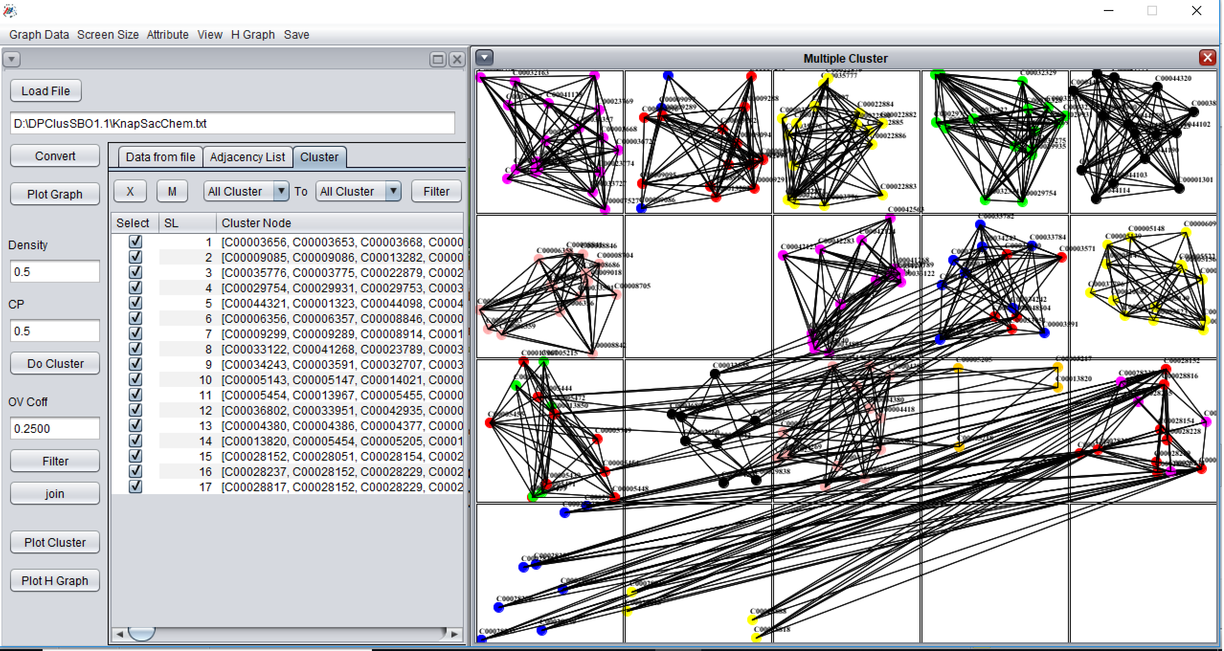

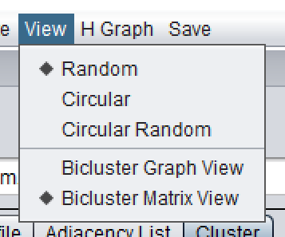Select different types of view (random, circular, Circular random) and click the button *plot*.

### Circular layout of cluster set

View individual cluster

Each cluster can be viewed in a magnifying window by double clicking its region.

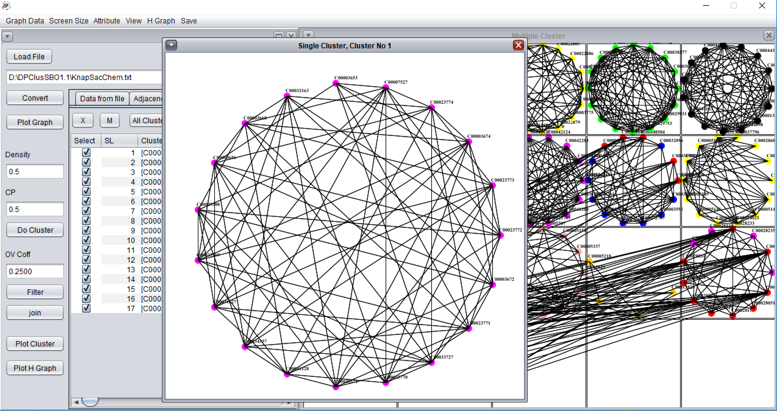

Double clicking the magnifying window also rearrange the node by selected layout. User can also select the edge property and font property from attribute menu item to change the node label and edge color for clear visibility.

Hierarchical cluster view: User can view the hierarchical relationships among clusters in terms of common neighbor by clicking the button *Plot H graph*.

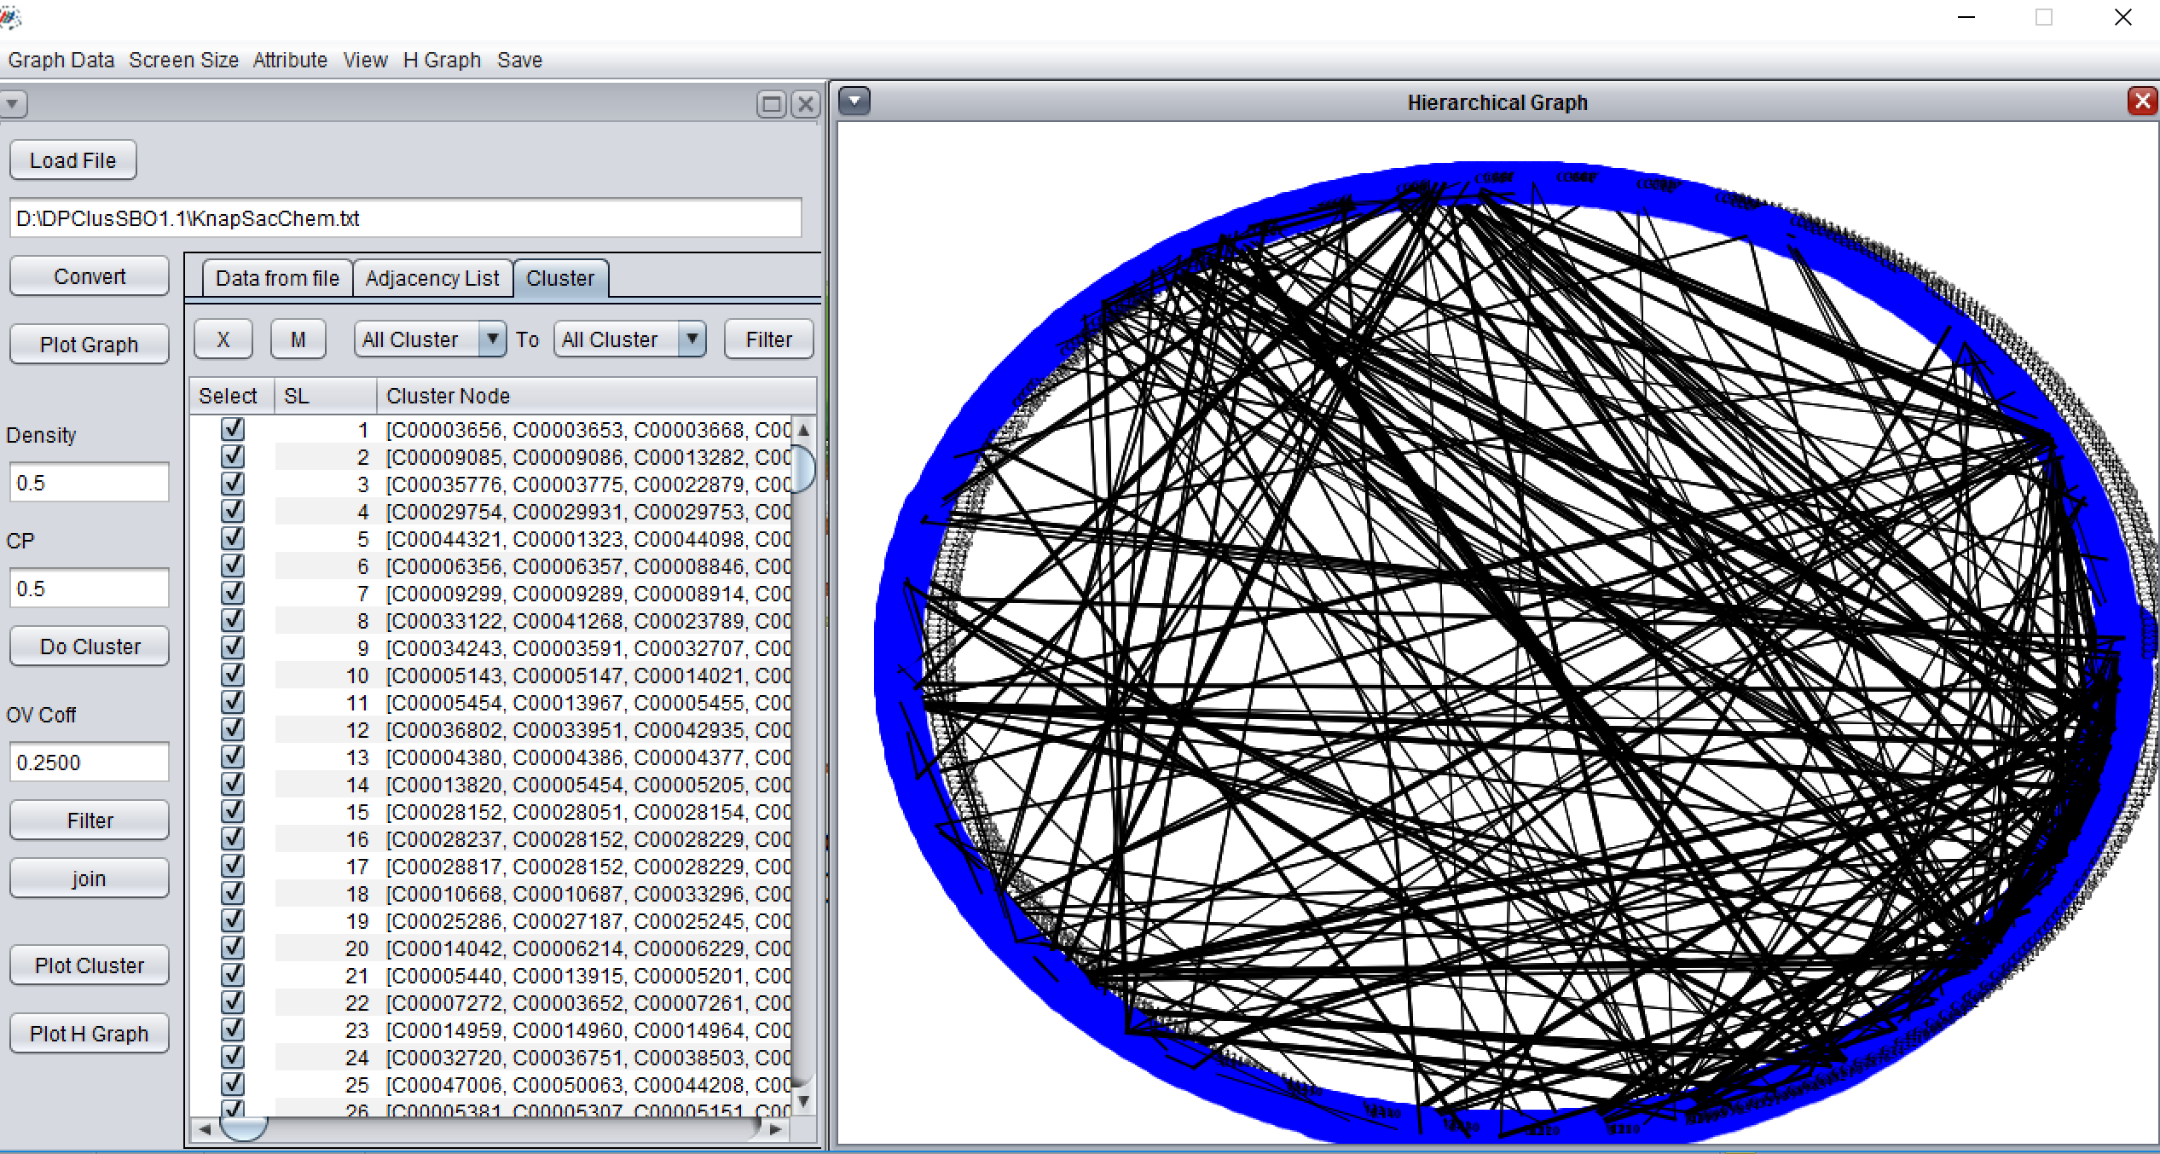

Hierarchical cluster node: Any nodes with their neighbor clusters in the hierarchical graph can be expanded by double clicking the corresponding node.

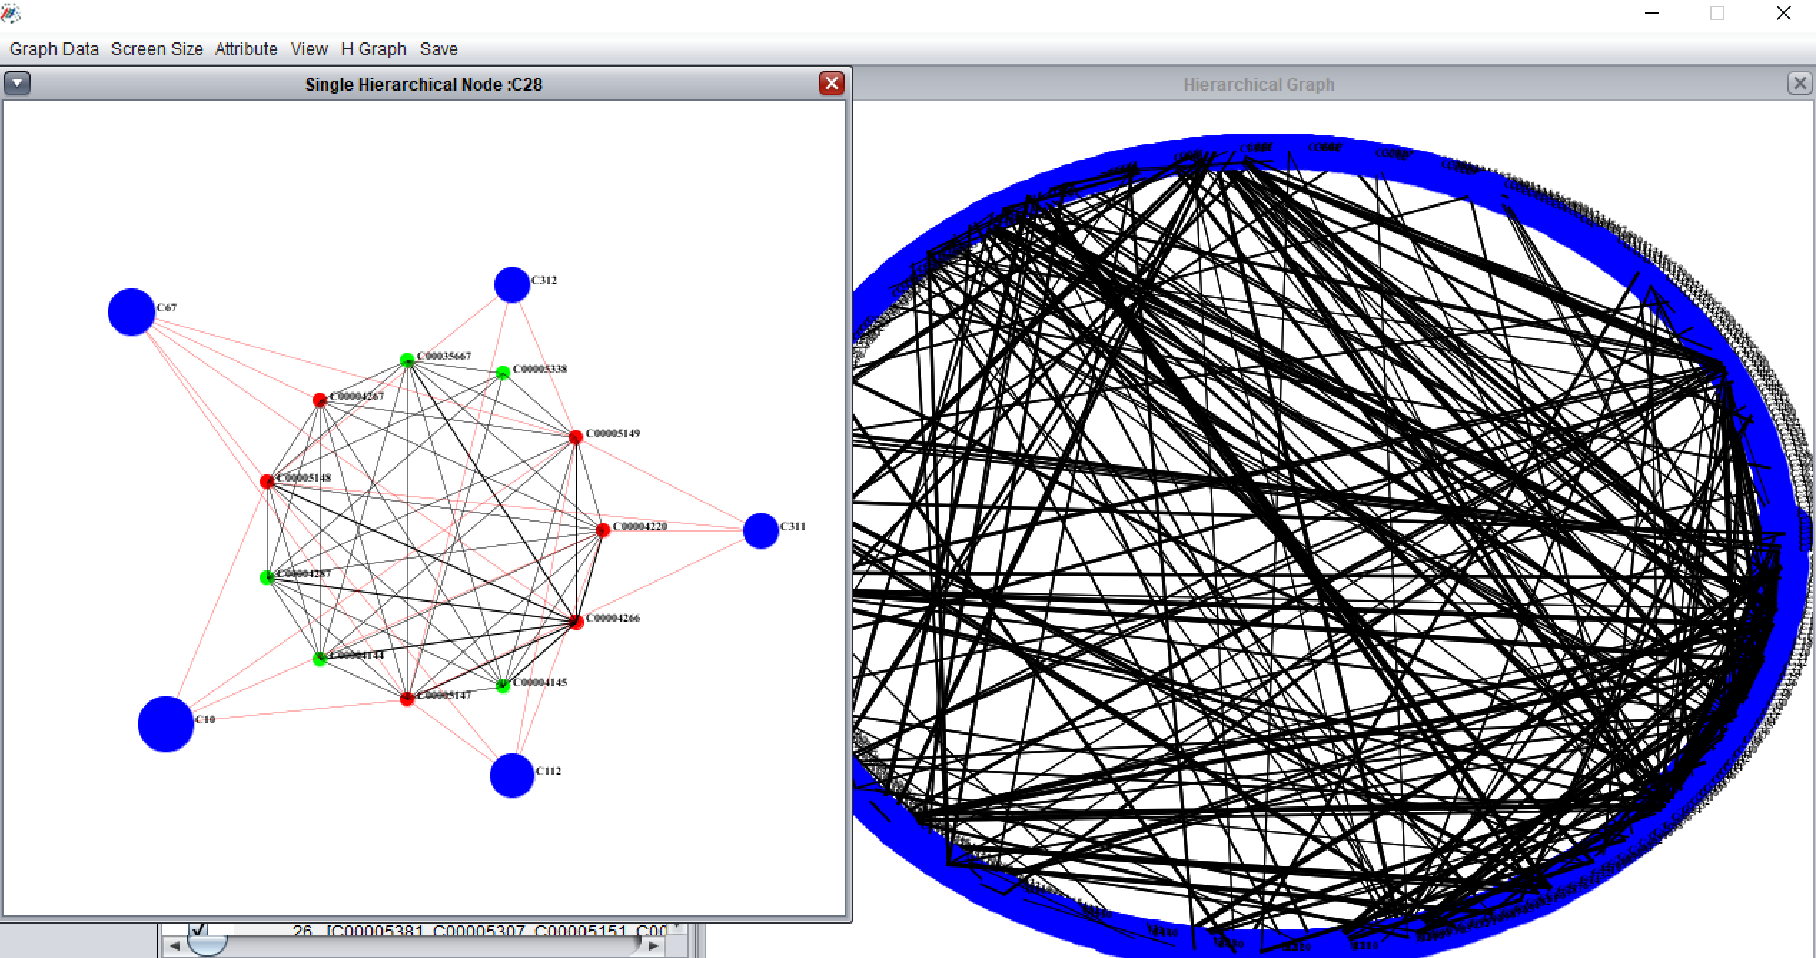

# 4. Bi clustering two way

The procedure for generating bicluster one-way and two-way is same hence we only describe here only two-way biclustering. The difference between one way and two-way biclustering is that one-way bi clustering considers only row-wise comparison to generate a simple graph whereas two-way bi clustering considers both row and column.

Select ***bicluster two sides*** from ***graph data*** menu item.

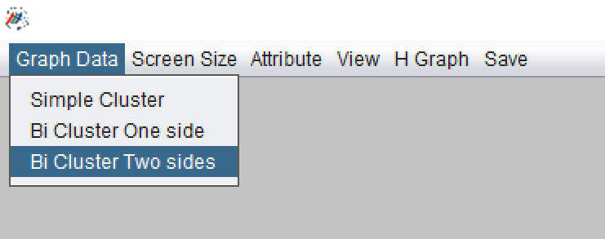

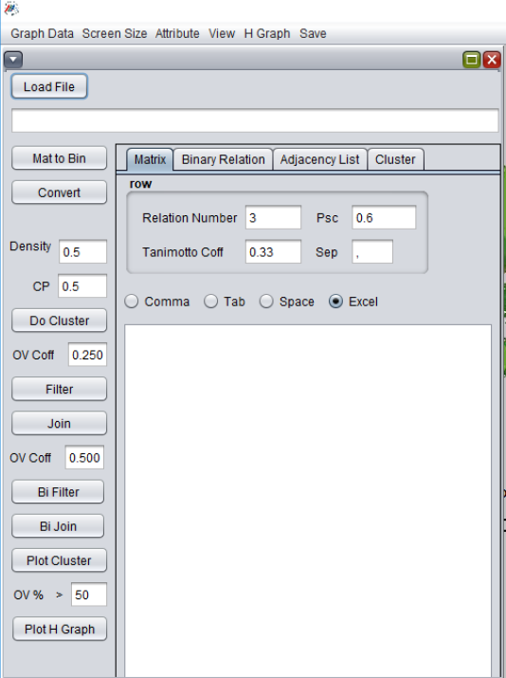4.1 Input file: The input file should be an excel file with the appropriate row and column label or two column tab, comma or space separated text file representing a bipartite graph. We show the example of using an excel file. Row and column label in the excel file represent the two node sets of a bipartite graph. 1 represents an edge between the corresponding row label and column label. A “0” must be present if there is no edge between row label and column label.

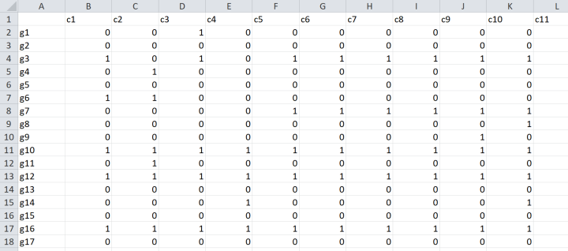

Click *load file* and select the excel file. Click *Mat to bin* to convert the data as a simple graph. Click *convert* to convert the simple graph as an adjacency matrix. Click *do cluster* to generate biclusters.

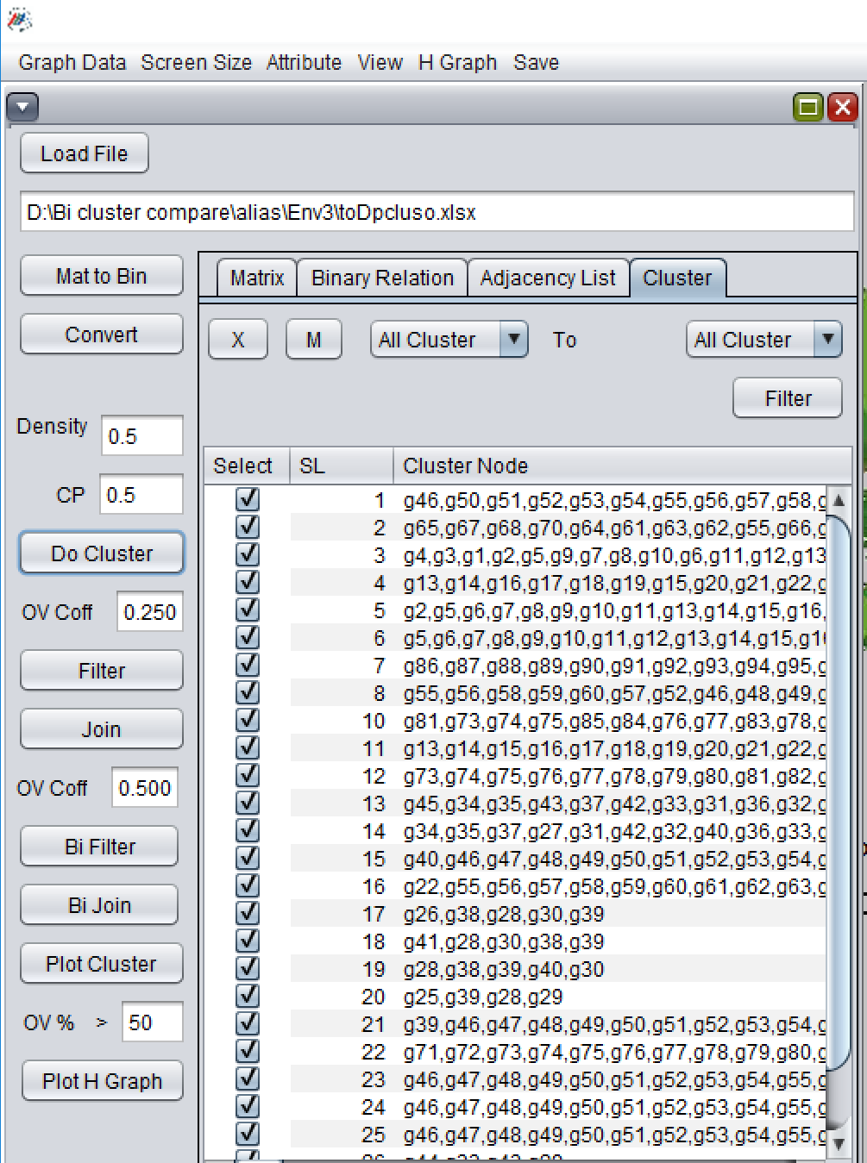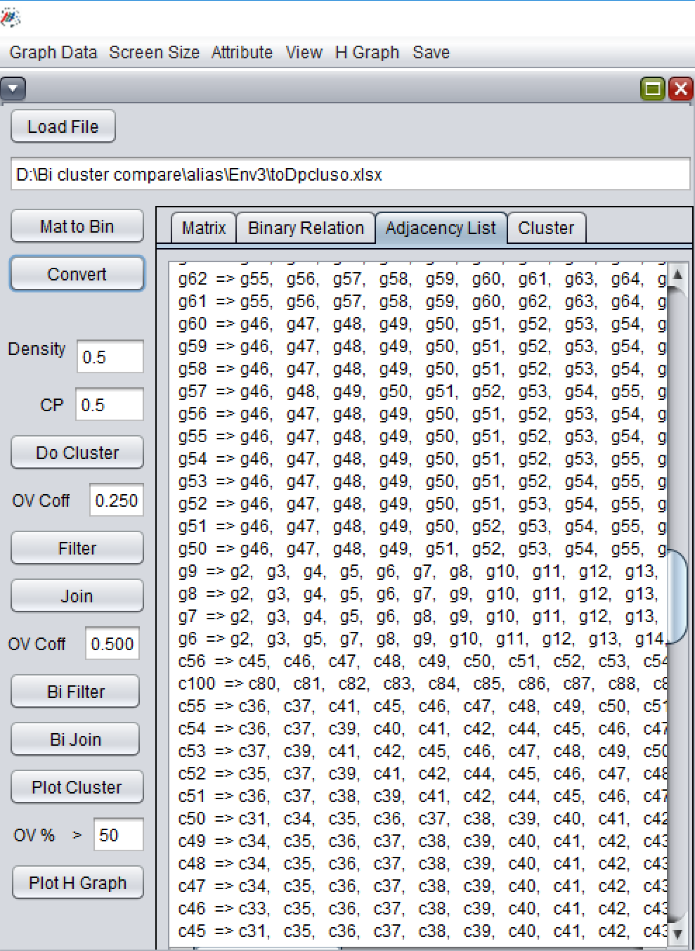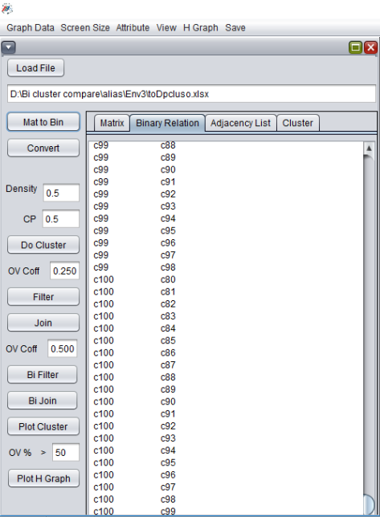

4.2 Filter/ Join: There are two coefficients to filter or join biclusters 1) DpClusO overlapping coefficient (Value 0.25 means more than or equal to 50 % similarities ) 2) Bi Cluster overlapping coefficient (Value 0.5 means more than or equal to 50 % similarities). User can use any one or both of them to filter and join biclusters

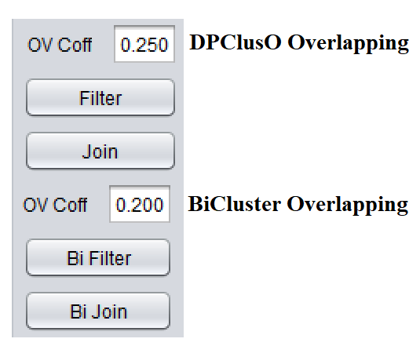

4.3 View bicluster: There are two types of view to render the bicluster set which are ***Bicluster Graph view*** and ***Bicluster Matrix view***. User can select any types of view from the view menu and click the *plot cluster*to render the bicluster set.

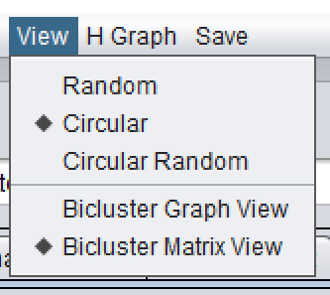

Matrix view: Matrix view arranges the biclusters by descending order according to their size and plot accordingly. 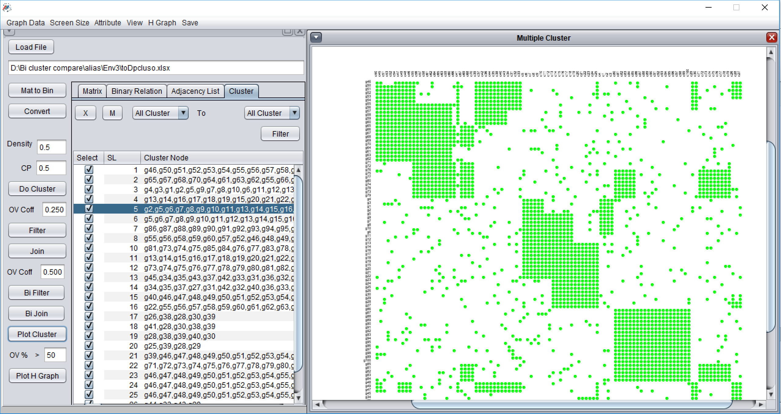

Graph view: Graph view renders the graphical view of each bicluster as a bipartite graph. Rendering window is divided by an equal sized small rectangle. Each rectangle renders a bicluster by placing each side of nodes by oval-shaped arrangement. Red nodes indicate the overlapping nodes. Each node is plotted only once hence some of the regions become blank as all of its nodes are somehow overlapped by other biclusters.

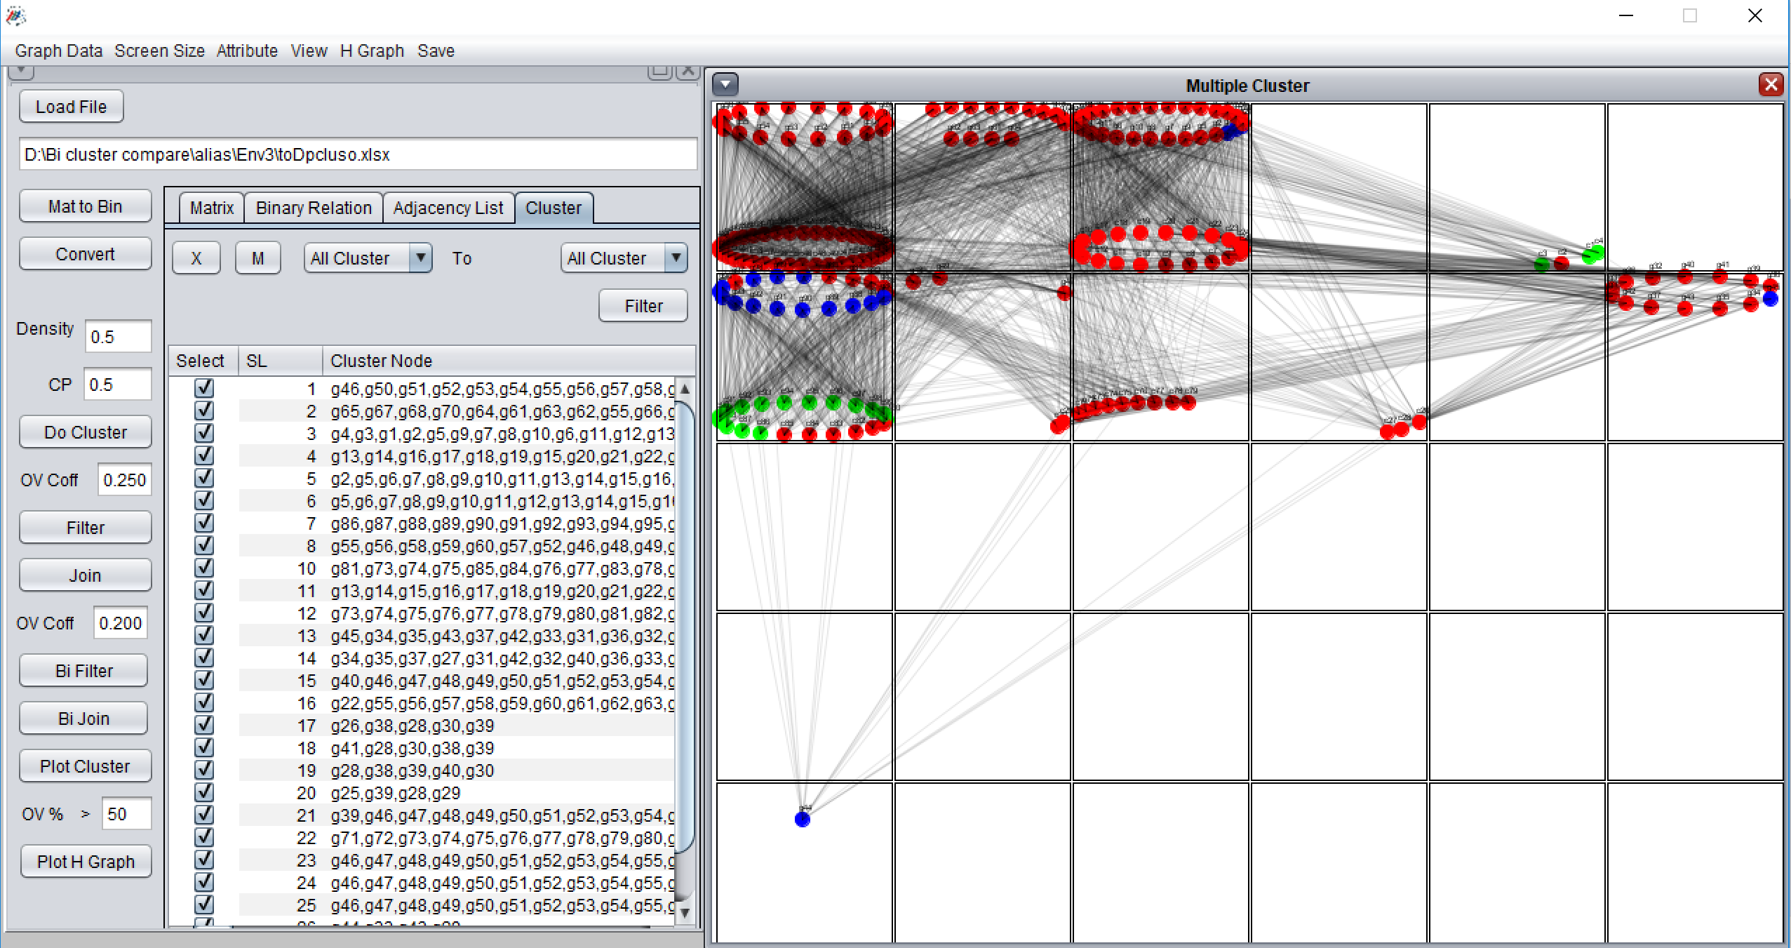

Single view of a bicluster: Double-clicking any region will produce a single view of the corresponding bicluster. Single view extracts all nodes including overlapping and renders a clear view of a bicluster. 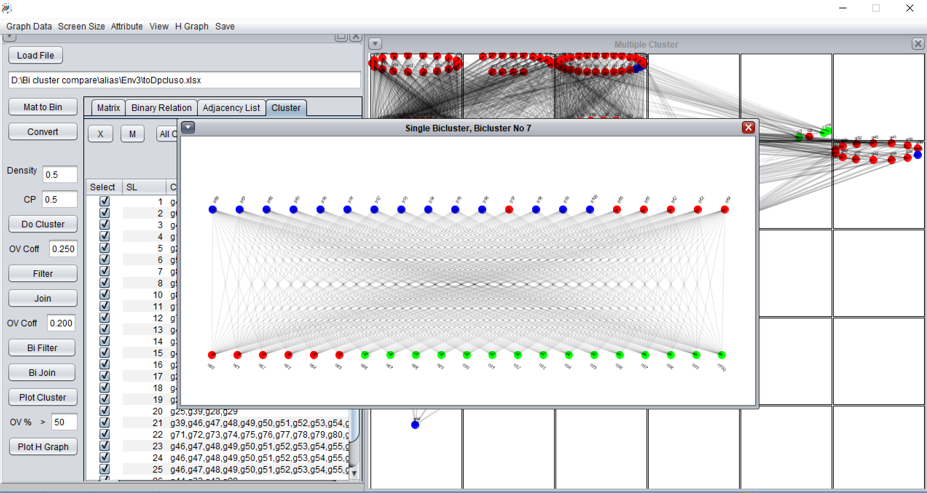

Hierarchical bicluster view: Hierarchical bicluster view renders the biclusters considering each bicluster as a node and overlapping measurement between two biclusters as an edge. The parameter in the text field “OV%” is used to calculate the minimum number of the overlapping percentage to be considered while drawing an edge. Edge thickness is proportional to the overlapping percentage between two biclusters. Enter the value as a percentage in the text field and click *Plot H graph*

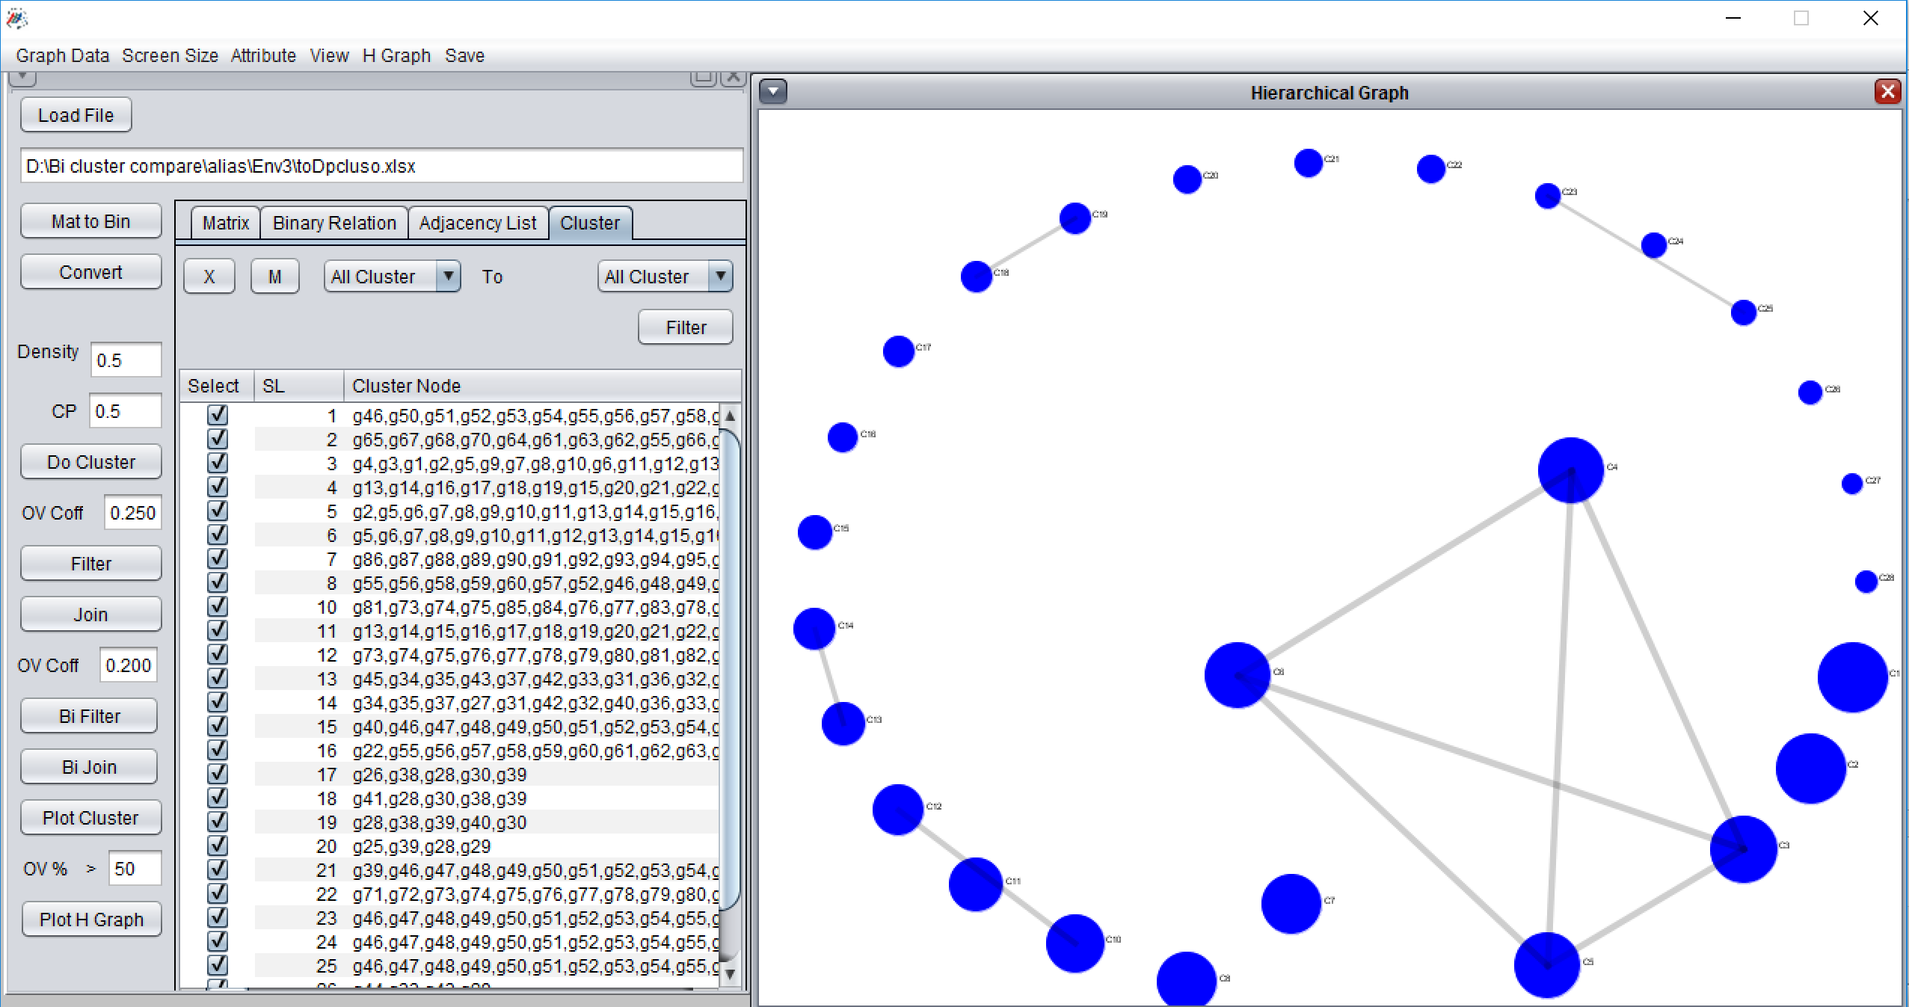

Hierarchical bicluster node: Click any node in the hierarchical view. A new window will appear expanding the selected node and its adjacent overlapping nodes where red nodes indicate the common nodes between two biclusters.

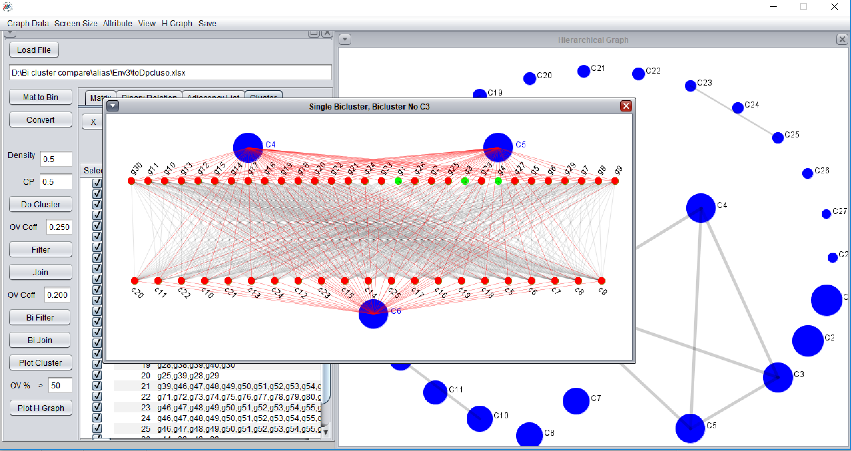

# **5. Save Image**

Menu item save option has different submenu to save the picture of different cluster/ Bicluster set, a single node of different cluster/ Bicluster, hierarchical relation of different cluster/ Bicluster set, a single node of the hierarchical graph of cluster/ Bicluster.

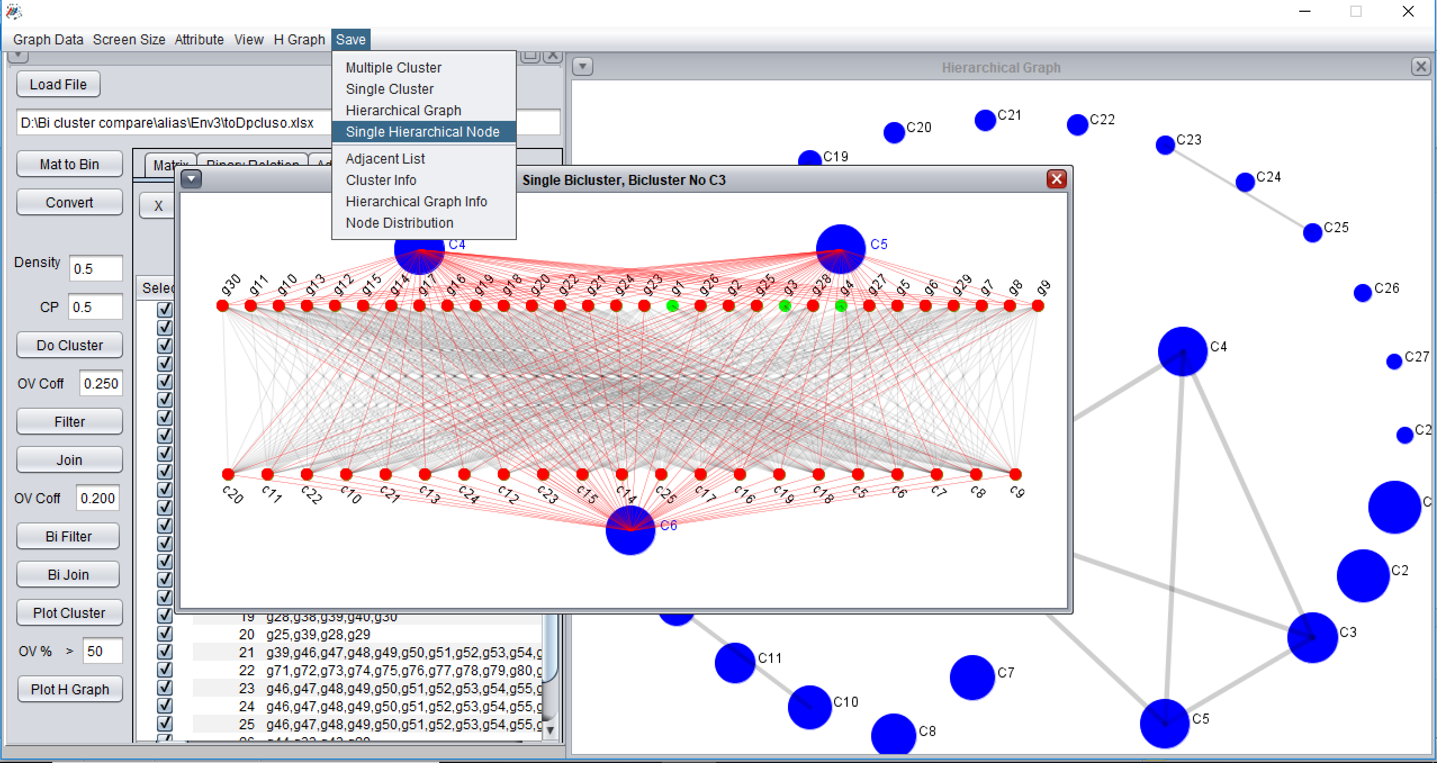

In order to save any picture, the user has to highlight the appropriate window by clicking the window header and select the corresponding submenu item from the Save menu. In this example, we first highlight the window of a hierarchical node and then click the sub menu Single hierarchical node to save the picture.